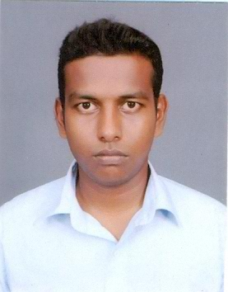
MR. JANITHA BUDDHIKA PERERA.
DATA OF BIRTH / AGE | 31st March 1989/ 26 years
SEX | Male
MARITAL STATUS | Single
ADDRESS | No : 147/6 Nugemulla Rd, Rukmale, Pannipitiya
CONTACT NO | 071-6198174 ( Mobile )0113103887 ( Home )
E-MAIL | janitha89@hotmail.com

ACADEMIC BACKGROUND

School attended: Dharmapala Vidyalaya , Pannipitiya for Advanced Level

Achievements
G.C.E Advanced Level Examination (2008)
  - Combined Maths C
  - Chemistry C
  - Physics S

School attended: CS/Kottawa North Dharmapala Vidyalaya for Odinary Level

Achievements
G.C.E Ordinary Level Examination (2005)
  - Buddhism A
  - Language & Lit C
  - English A
  - Science & Tech B
  - Mathematics A
  - Soc. St & History A
  - Music ( S ) C
  - History A
  - Business & Accounts A

QUALIFICATIONS

DETAILS
- Successfully Completed a Diploma In Video Editing Course at Teleview Academy.

- Successfully Completed a Diploma In 3D Animation Course at Teleview Academy.

- Successfully Completed a Diploma In Graphic Designing Course at Ingrin Institute.

- Ability of Reading, Speaking and Understanding English

Extra-Curricular Activities
- Member of School Volleyball Team.

- Member of School Media Society.

- Member of the School Cricket Team.

- Member of Computer Society.

Work Experience
- Permanente Graphic Designer & Video Editor at Sip Piyasa E-Learning (Pvt) Ltd. Since
02nd June 2011 to 24th January 2013.
- Now, Work as a Graphic Designer at Apex Technologies (Pvt) Ltd. Since
17th December 2013 to Present.

Non Related Referees
Mr. R.A.D Karunasena  Principal  Rukmale Maha Vidyalaya  Rukmale,  Pannipitiya.  Tel: 0115-643623 (Office)  0112-760813 (Home) | Mrs. W.M Sriyalatha Weerasinghe  Stenographer – Class I ( retired government )  157/7 Nugemulla Road,  Rukmale  Tel: 011-2898788 ( Home )

Finally, I would appreciate if you could call me for an interview where I will be able to express my abilities and interests further. I am looking forward to hearing from you.

Thanking you,
Yours faithfully,
Janitha Buddhika Perera

